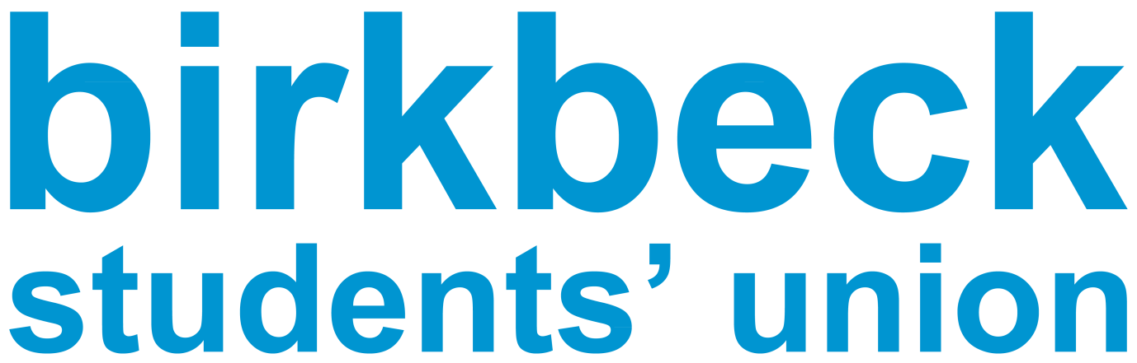
(MOTION FOR Parliament June 2024)
Title: That Birkbeck student parliament issue a clear and powerful statement of support and solidarity to those marching for peace and a long-term ceasefire in the Gaza strip
Proposer: Floyd Codlin (Environmental & Ethics Officer)
Seconder: Ella Barnes

Council believes:

Since October the 7th Israel has accelerated its ethnic cleansing campaign against Palestinian people. Which is why ending the 76-year occupation, which is the root cause of the conflict, should be imperative. The 76-year occupation is the root cause of the conflict has led us to this massive loss of life.

The strip contains (contained) over 2.3 million Palestinians and over 36,000 have been killed, over 15,000 of them children (these are under estimates). Over 42% of those killed have been women and children. There are also said to be several thousand Palestinian people still buried under the rubble. Furthermore, the Palestinians in Gaza, have been under full siege by Israel since 2005/6. They have no airport, no sea port, no land port, limited food access, water and energy, which is under Israeli control, and subject to the Israeli political decisions. Israel is not only the occupying power under Geneva Convention, the occupying power should be responsible for the people under occupation

- It should also be noted that in the context of education, that the Israeli state is guilty of scholasticide, which is the indiscriminate killing of students and professors. We are being asked to bear witness to the destruction of knowledge and identity. Up until April 2024, according to the United Nations human rights, 80% schools have been destroyed, 5.5 thousand students killed and almost 100 university professors. https://www.ohchr.org/en/press-releases/2024/04/un-experts-deeply-concerned-over-scholasticide-gaza
- Based on statements made by currently serving Israeli government ministers it appears that Israel is determined to ethnically cleanse Palestinian land. Their actions are in constant violation of international laws and are arrest warrants are issued for, example Benjamin Netanyahu. This has happened without any condemnation or action from the UK government and despite the Israeli calls for genocide, which has been highlighted by the ICJ considered. That is why there should be a strong condemnation of the Israeli government and its actions.

Council further believes:

- That the right and far right, have used the current conflict to sow fear in the Jewish and Muslim communities. The organisation Namod has provided a really positive example of countering the hate campaigns; https://naamod.org.uk/who-we-are/

Council resolves:
- That BBK Student Parliament works with the anti-racist/anti-fascist and the Environmental & Ethics Officers on drafting a statement in which the parliament condemns the sharp rise of both antisemitism and Islamophobia

- That BBK Student Parliament will also join the voices condemning the attempts to ethnically cleanse the Palestinians from the Gaza strip and the West Bank

- That BBK Student Parliament will issue a statement of solidarity to any of the main unions/or student and staff organisations here and at other universities, who have been in danger of either being vilified, or disciplined for lawful Palestinian solidarity activity. Also, that this solidarity also applies to those who are in fear of taking part in pro-Palestinian activity on campuses, including that of Birkbeck

- That BBK Student Parliament also resolves, to support where practical, campaigns calling on British universities, including Birkbeck to disinvest from arms, and military software, logistic, and financial companies and boycott any links to Israeli universities and colleges.

See below links for more information
https://linktr.ee/bbk4palestine?utm_source=linktree_admin_share
https://docs.google.com/forms/d/e/1FAIpQLSeZ12hNwlvUhTR-NBqZWw9bgl6rPVAxMo4n3bfErdYQ284tcw/viewform

https://docs.google.com/forms/d/e/1FAIpQLSddjE8QuktdtkjtT6WR-oa30C0_jUUlOZXkFlDuqKEnGHlGiw/viewform

https://www.instagram.com/sew4palestine/?hl=en-gb

https://www.declassifieduk.org/explained-the-1bn-plus-deals-between-uk-universities-and-the-arms-trade/

https://bylinetimes.com/2021/08/18/uk-universities-received-at-least-190-million-from-major-arms-manufacturers-in-past-eight-years/
https://www.instagram.com/birkbeck4palestine/?hl=en-gb

